**SQL- Willians Eleno**

Given this ER

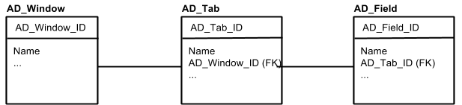

Write the following SQL queries:

1. Name of window with AD_Window_ID = ‘100’
2. Update window with AD_Window_ID = ‘100’ appending ‘--’ to the name of window with AD_Window_ID = ‘100’
3. List of all tabs in window with AD_Window_ID = ‘100’
4. List of tab name + field name of all tabs in AD_Window_ID = ‘100’ sorted by tab name and field name
5. Name and number of tabs of all windows
6. List of all windows with its number of fields, sorting by number of fields starting by the windows with a higher number of them
7. Windows with more than 5 tabs

***Respuestas:***

**1-** SELECT Name

FROM AD_Windows

WHERE AD_Window_ID = 100

**2-** UPDATE AD_Windows

SET Name = Name || '--'

WHERE AD_Window_ID = 100

**3-** SELECT *

FROM AD_Tab

INNER JOIN AD_Windows

ON AD_Tab.AD_Window_ID_FK = AD_Windows.AD_Window_ID

WHERE AD_Windows.AD_Window_ID = 100

**4 -** SELECT AD_Tab.Name, AD_Field.Name

FROM AD_Tab

INNER JOIN AD_Field ON AD_Tab.AD_Tab_ID = AD_Field.AD_Tab_ID_FK

WHERE AD_Tab.AD_Window_ID_FK = 100

ORDER BY AD_Tab.Name, AD_Field.Name

or

SELECT AD_Tab.Name, AD_Field.Name

FROM AD_Tab

INNER JOIN AD_Field ON AD_Tab.AD_Tab_ID = AD_Field.AD_Tab_ID_FK

INNER JOIN AD_Window ON AD_Tab.AD_Window_ID_FK = AD_Window.AD_Window_ID

WHERE AD_Window.AD_Window_ID = 100

ORDER BY AD_Tab.Name, AD_Field.Name

**5-** SELECT AD_Windows.Name,

COUNT(AD_Tab.AD_Tab_ID)

FROM AD_Windows

LEFT JOIN AD_Tab ON AD_Windows.AD_Window_ID = AD_Tab.AD_Window_ID_FK

GROUP BY AD_Windows.Name

**6-**SELECT AD_Windows.Name,

COUNT(AD_Field.AD_Field_ID)

AS Field_Count

FROM AD_Windows

LEFT JOIN AD_Tab

ON AD_Windows.AD_Window_ID = AD_Tab.AD_Window_ID_FK

LEFT JOIN AD_Field

ON AD_Tab.AD_Tab_ID = AD_Field.AD_Tab_ID_FK

GROUP BY AD_Windows.Name

ORDER BY Field_Count DESC

Aclaración: Tuve que hacer dos left Join porque la tabla windows no tiene relación directa con la tabla Field

**7-** SELECT AD_Window_ID, Name,

COUNT(AD_Tab_ID)

AS Tab_Count

FROM AD_Windows

JOIN AD_Tab

ON AD_Windows.AD_Window_ID = AD_Tab.AD_Window_ID_FK

GROUP BY AD_Window_ID, Name

HAVING Tab_Count > 5